European Championships Show & Precision 2011

Gondomar (Oporto) - Portugal

Programme – Version 1 / 09.03.2011:

Thursday 05 / 05 / 2011

10.30 – 23.00 hrs Training for Youth Gr., Quartet, Junior Prec. & Large Gr. categories
15.00 and 19.00 hrs Cleaning of the rink

15.00 – 19.30 hrs Registration & Payments of ALL Clubs
(Important - Club not registered in time will be excluded from the draw)

20.00 hrs Draw (Important!!! - Allowed for each Nation max three (3) delegates)

Friday 06 / 05 / 2011
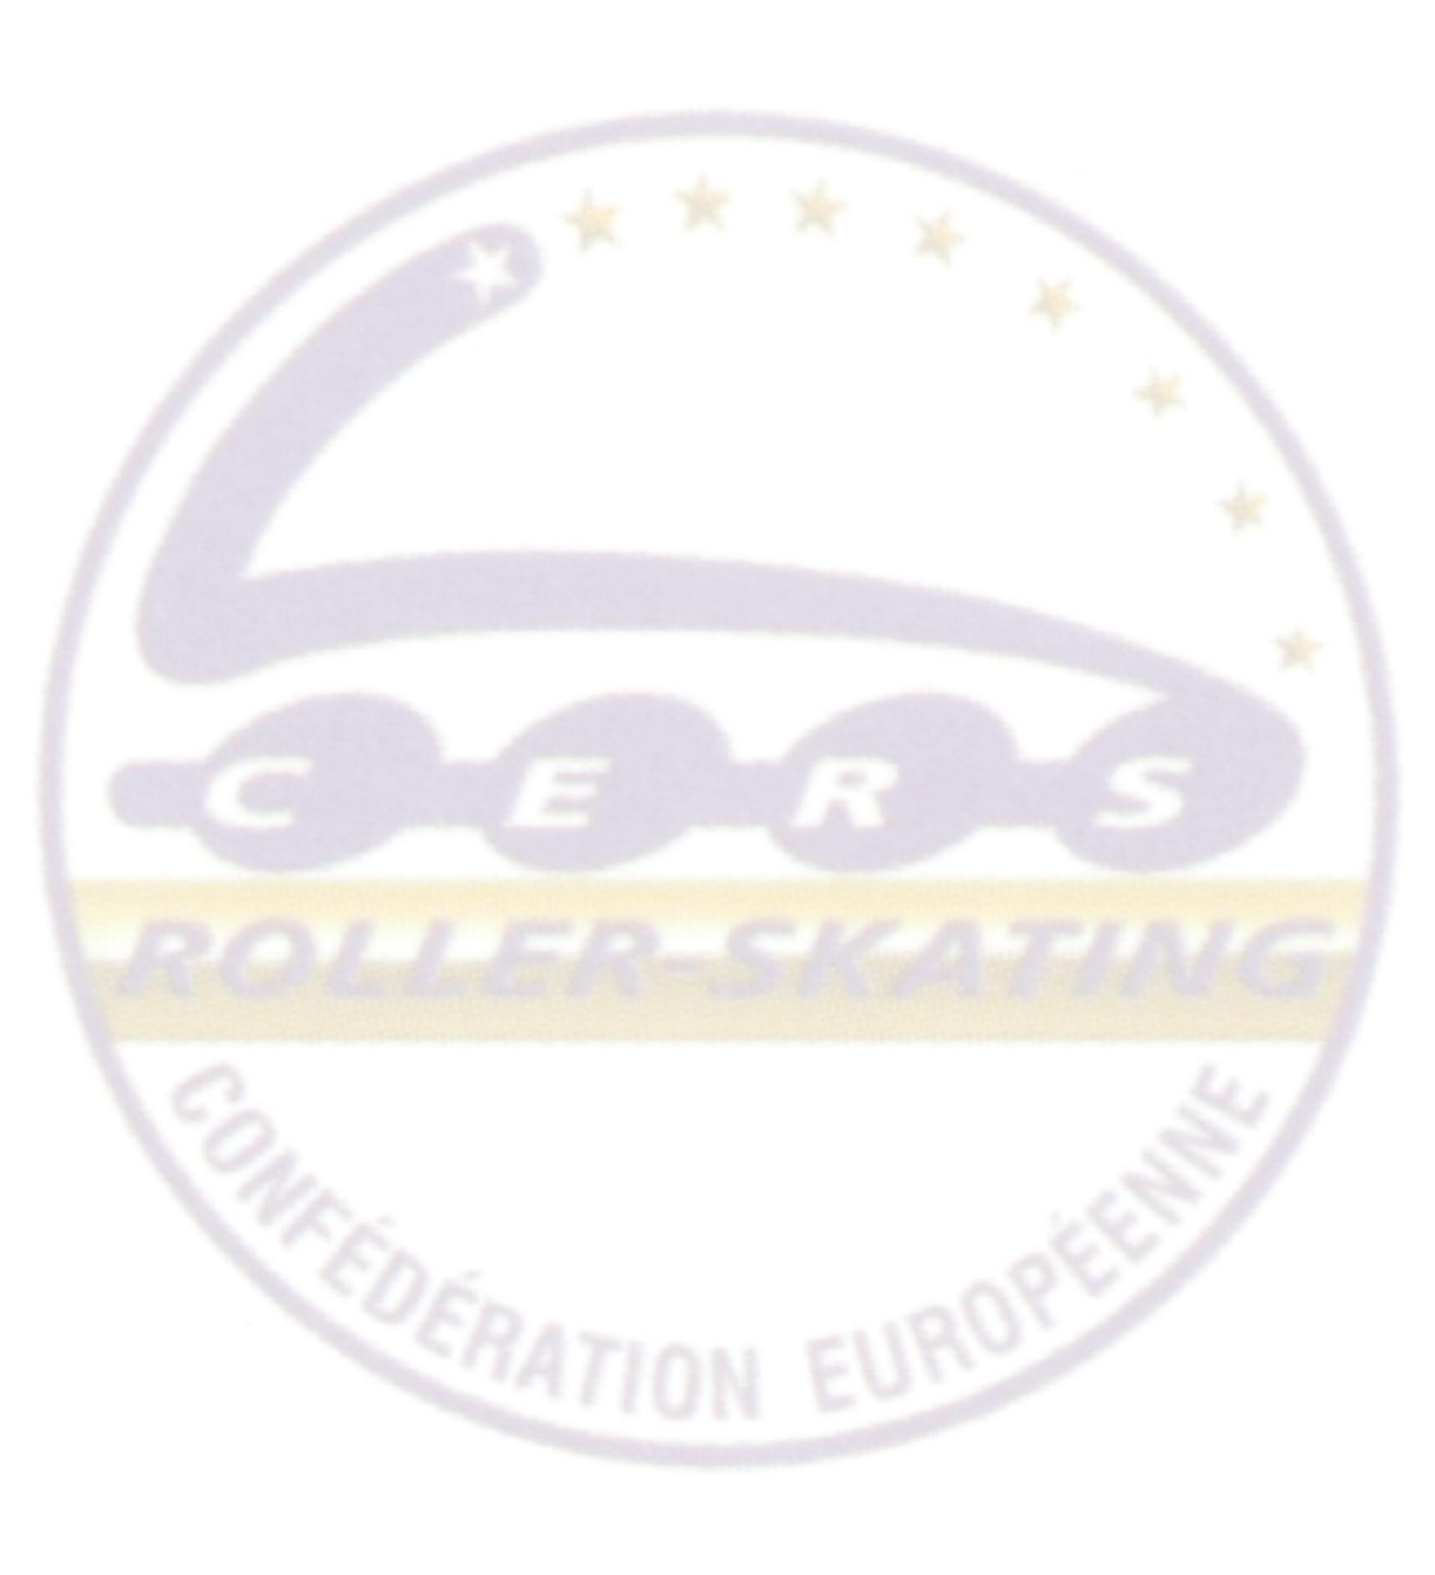
08.30 – 14.00 hrs Training for Small Groups category

11.30 Cleaning of the rink

10.00- 11.30 hrs Judge Meeting

14.00 Cleaning of the rink

14.30 – 15.55 hrs Competition Youth Groups (expected 12)

16.05 – 17.45 hrs Competition Quartet (expected 17)

17.45 Cleaning of the rink

18.00 – 19.35 hrs Competition Junior Precision (expected 11)

20.00 – 21.00 hrs Opening Ceremony

21.00 Cleaning of the rink

21.15 - 23.00 hrs Competition Large Groups (expected 13)
Followed by Podium: LARGE GROUPS

Saturday 07 / 05 / 2011

08.30 – 14.15 hrs Training for Cadet Quartet & Senior Precision categories

11.30 Cleaning of the rink

10.00 – 12.30 hrs Delegate’s & Trainers Meeting

14.15 Cleaning of the rink

14.30 – 16.00 hrs Competition Cadet Quartet (expected 15)

16.05 – 18.45 hrs Competition Small Groups (expected 20)

18.45 Cleaning of the rink

19.00 – 20.25 hrs Competition Senior Precision (expected 10)

Followed by Podiums & Closing Ceremony

